

+91 9313035076, +91 9537651265

[info@bkexportsinternational.com](mailto:info@bkexportsinternational.com) [www.bkexportsinternational.com](http://www.bkexportsinternational.com/)

90, Jasodanagar Cross Road, Nr. Canal, Opp. Baroda Express Highway, Amraiwadi, Ahmedabad, Gujarat, India - 380026

**DT: 08-03-2025**

**TO,**

**EXPORT INSPECTION AGENCY**

**AHMEDABAD.**

**SUB: Retrospective CoO**

**DEAR SIR,**

**We have apply Asian India Free Trade Agreement (AIFTA) IN Retrospective mode Because BL RECEVEID LATE FROM SHIPPING AGENT.**

**SO PLEASE ISSUE CERTIFICATE.**

**REGARDS,**

**FOR B K EXPORTS.**

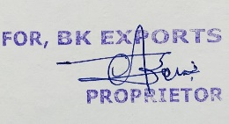

**PROPRITOR**

**ALPESH JAIN**